ST. JOE FLAME REACTOR PROCESS

**TSUMEB LEAD BLAST FURNACE SLAG**

**FUMING PROGRAM.**

Submitted to:

Leonard Harris, Newmont Mining Corporation

Submitted by:

Robert Chew and John Pusateri

November 1987

**TABLE OF CONTENT**

SUMMARY ............................................................................. Section I

PROGRAM OBJECTIVES .......................................................... Section I I

FLAME REACTOR OPERATIONS ...............................................Section III

PLANT TRIALS PROGRAM.........................................................Section IV

SLAG FEED AND FUEL CHARACTERIZATION..............................Section V

TEST OBSERVATIONS ..............................................................Section VI

METALLURGICAL PERFORMANCE ..........................................Section VII

RECOMMENDATIONS............................................................ Section VIII

SECTION I

SUMMARY

During August 8-10, 1987, we conducted a test program at the Flame Reactor plant, Monaca, Pennsylvania, USA, for the Tsumeb Corporation Limited, South West Africa/Namibia. The objective of this test program was to evaluate the capabilities of the St. Joe Flame Reactor to fume Tsumeb lead blast furnace slag and recover valuable germanium, gallium, zinc and lead a product oxide. Target metal recoveries to oxide were 80% Ge, 40% Ga, 90% Zn, and 85% Pb.

In total, about 51 tons of milled slag and 9 tons of coarse slag were treated at the St. Joe Flame Reactor demonstration facility located in Monaca, Pennsylvania. Treated gallium, milled slag averaged 450 ppm 10.3% zinc and 2.3% lead. For germanium, 140 ppm the selected test matrix of operating conditions (eight test points), material balances for product crude oxide were:

|  |  |  |  |  |
| --- | --- | --- | --- | --- |
|  | Average | Range | Average | Range |
| Germanium | 1570 ppm | 1350 - 2160 | 57.0% | 40.4 -76.2 |
| Gallium | 80ppm | 70 - 80 | 9.1% | 6.7 - 10.0 |
| Zinc | 39.8 % | 37.2 - 43.3 | 63.1% | 51.8 - 76.4 |
| Lead | 13.1% | 11.9 - 15.7 | 87.2% | 77.7 - 99.9 |

Overall, germanium, gallium and zinc recoveries to product oxide were not as good as anticipated. During testing, some difficulties were encountered with premature coal ignition which destabilized coal feed and combustion. This deficiency in combustion system control was considered the main cause for low metal recoveries.

We believe that the Flame Reactor Process for treating lead blast furnace slag showed good potential to economically and efficiently recover metal values. We recommend initiating a second slag fuming test program to include the following:

(1) SMELTING TESTS WITH COKE FINES (where stable fuel combustion is obtainable with the existing burner geometry) to delineate the effects of fuel type (coke versus coal) on Flame Reactor combustion stability and smelting performance, and

( 2 ) SMELTING TESTS WITH COAL (similar to Tsumeb nut coal) and with an improved burner section tailored toward coal combustion. We are currently initiating the burner test program to develop and operate the new burner designs.

smelting tests on a small (20-25 ton) lot of Tsumeb slag could be conducted in early 1988 with the improved coal burner.

These recommendations will be described in more detail in Section VIII and in the commercial proposal to be sent in late December.

The technical objectives for the program were to operate the Flame Reactor Process with Tsumeb lead blast furnace slag to demonstrate process capabilities and to investigate the effects of operating conditions on the recovery of valuable metals, especially germanium and gallium, as an oxide product. From discussions with Tsumeb management, target recoveries were 80% Ge, 40% Ga, 90% Zn, and 85% Pb.

Specifically, we would perform slag fuming tests at the Flame Reactor Process demonstration facility at Monaca, Pennsylvania. Product oxides and slags would be obtained to generate metallurgical and operating data to evaluate process performance. Valuable germanium, gallium, zinc and lead would be recovered in the crude oxide. Non-volatile materials, such as calcium, iron and silicon, would report to the product slag.

These products would be used by Tsumeb for subsequent process testing and evaluation, including: (1) oxide leaching for germanium recovery, and (2) slag testing for use as a cement ingredient.

During the plant preparations and testing, Chris Viljoen, research metallurgist for Tsumeb, was on site and gave much input to the test program and evaluations. Also, Robert Haegele, Chief Metallurgist and Tom Owen, Consultant with Consolidated Gold Fields, also observed three days of operations. Len Harris of Newmont Mining observed a day of pre-test on August 13.

The Flame Reactor Process is an integrated, two-stage system, see Sketch A.

Coal/coke and oxidant are injected into the first stage. In the first stage coal/coke fines gasification is initiated, stabilized and essentially completed. The majority of the

reactor heat and gaseous reductant (i.e., co and H2) are produced in this stage called the "Burner" section.

Metallurgical feed is injected into the second stage where smelting reactions occur. Specifically, for lead blast furnace slag treatment, germanium, gallium, zinc, and lead are fumed into metal vapors. Gangue constituents are fused into molten slag. This section is called the "Reactor" section.

Products of the smelting reactions exit the bottom of the reactor and enter a separator. Gases are separated from the molten slag. These gases include germanium, gallium, zinc, and lead metal vapors, co, co2, H2, H20 and N2. After exiting the separator, the gases are after-combusted and cooled. A crude metal oxide product is formed (along with co2, H2o and N2) and is composed of the valuable germanium and gallium, zno and lesser amounts of PbO. The oxide is collected in a baghouse and clean off-gases are exhausted to atmosphere. Molten slag, primarily iron oxides, is continuously tapped from the separator, solidified, cooled and stored.

Sketch A: ST. JOE FLAME REACTOR

PROCESS SCHEMATIC

SECTION IV

PLANT TRIALS PROGRAM

Flame Reactor Process trials included plant preparation, tests on a matrix of operating conditions, sampling and chemical analysis, test data analysis and plant cleanup. Product shipment, commercial plant cost estimates and a commercial proposal are discussed in a separate report.

An initial test matrix of operating conditions was included in an Agreement between Newmont and St. Joe. A final test matrix containing eight ( 8) test points was agreed upon

between Newmont, Tsumeb and St. Joe personnel during discussions in Monaca, see Table #1. Operating parameters included:

(1) Slag feed rate (lbs./min),

(2) Oxidant composition (% o2),

(3) Reactor gas reducing strength (CO/co2 ratio), and

(4) Reactor operating temperature (deg-C).

It was agreed upon with TCL people to target for high CO/CO2 ratio and high operating temperature to maximize theoretical zinc recovery. Based on results from early laboratory/pilot fuming tests by Tsumeb, it is important to note that germanium recovery was assumed to parallel zinc recovery. Hence, we anticipated that operating conditions that favored high zinc recovery would also favor/improve germanium recovery, e.g. high co/co2 ratio and operating temperature.

We planned to operate each test point for about three hours; one hour to equilibrate after changing operating conditions and two hours to collect representative samples during steady-state operations.

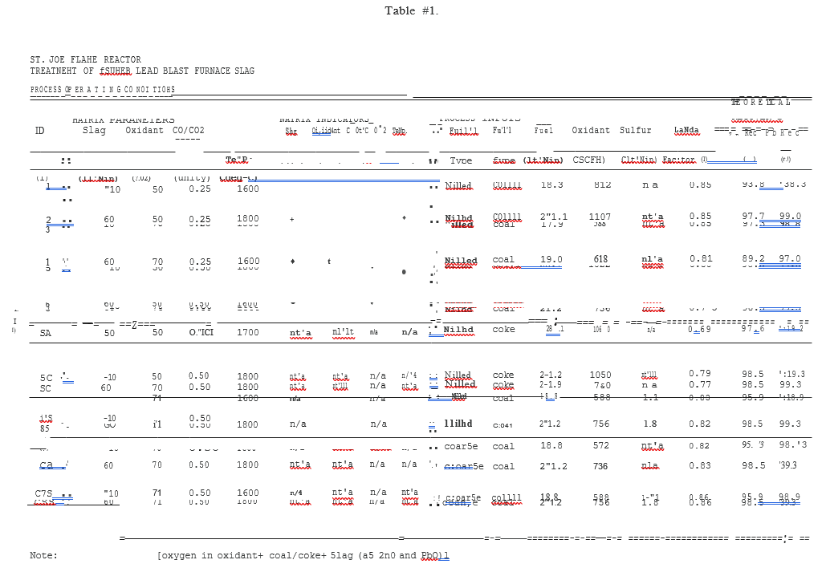

One important change in operations made for this test matrix was the use of fine coal as fuel, as requested by Tsumeb, in place of the usual coke fines

Additional fuming tests were performed with coarse slag, coke fines and/or sulfur additions to further evaluate process.

SECTION V

SLAG FEED AND FUEL CHARACTERIZATION

In total, about 51 tons of milled slag and 9 tons of coarse slag were received at St. Joe. Germanium, gallium, zinc, lead and iron assays of early slag samples ( 2/87 and 4/87) and current slag samples (8/87) are briefly summarized in Table #2 and detailed in Table #3. Milled slag averaged 450 ppm germanium, 1140 ppm gallium, 10.3% zinc and 2.3% lead. There were slight differences in assays among samples. Most notable were the 210+ ppm Ga levels in the 2/87 and 4/87 samples versus the 140+ ppm Ga in the 8/87 samples. These differences were most likely due to either variations in samples and/or laboratories. All samples were taken from the Tsumeb stockpile, including the 51-ton test lot, and shipped to Monaca.

Size distributions reported by Tsumeb and St. Joe were very comparable for each slag type as shown in Table #2 and Figure A. The target size for milled slag of greater than 70% -200 mesh was satisfied.

An electron microprobe evaluation of the Tsumeb slag was performed ( by J. W. Ahlrichs, Newmont Metallurgical Services, Salt Lake City, Utah) in an attempt to identify gallium phases. After numerous scans, no discrete gallium phases were detected. It was suggested that the gallium was finely dispersed in a solid solution within the slag. Note that the reported 150 to 200 ppm level of gallium is well below the detection limits of the microprobe.

A commercial-scale Flame Reactor plant would most likely be fired with nut coal as used at the Tsumeb smelter. In lieu of shipping nut coal to the U.S. for testing, one requirement of the program was to utilize a U.S. coal similar to the nut coal. Analyses of the actual coal used, along with coke breeze used during the program, are summarized in Table #4. As shown, proximate analyses of the nut coal and U.S. coal were similar. In the U.S. coal, ash content was slightly lower and volatile matter and fuel content slightly higher.

TSUMEB SLAG SIZE DISTRIBUTION

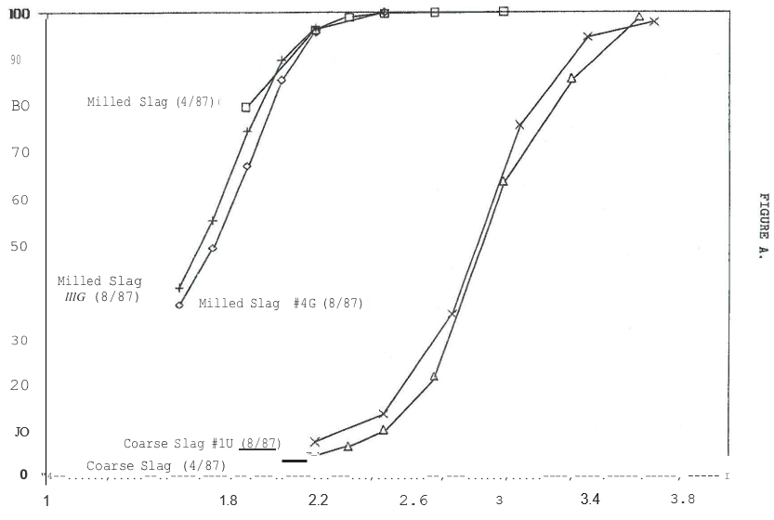

Particle Size log of

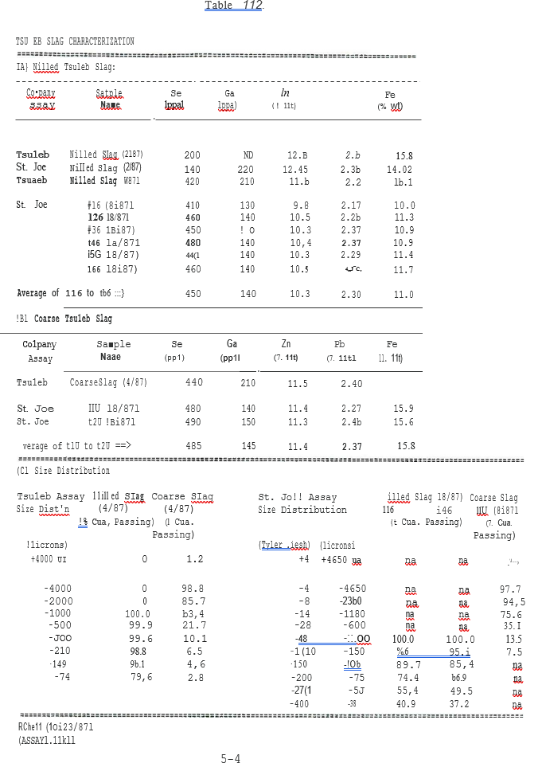

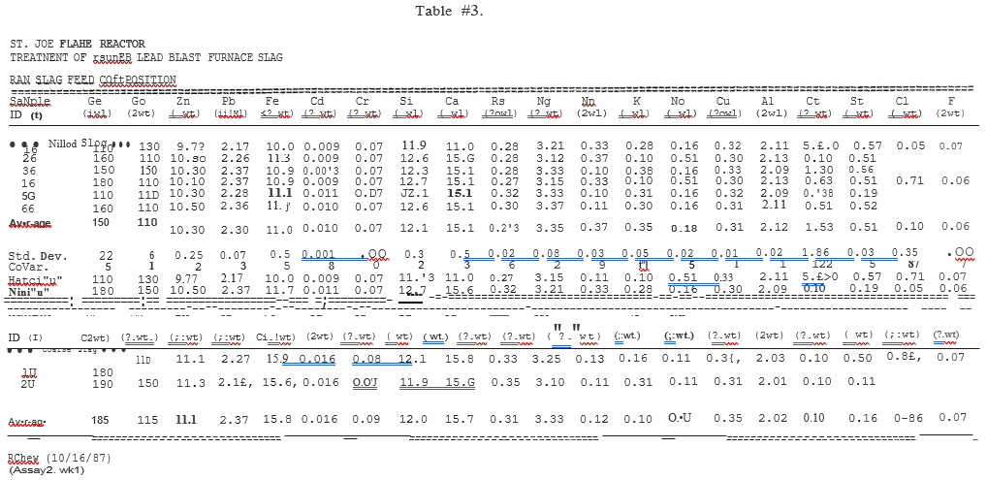

SECTION VI

TEST OBSERVATIONS

This section provides a review of significant qualitative operating observations during the test program. Quantitative results such as metallurgical performance are discussed in Section VII.

On August 13, 1987, the first smelting test with Tsumeb slag was completed while firing the Flame Reactor Process with coke fines, i.e., Test point #SA. While the Flame Reactor plant was operated extensively on coal during 1983-84, coke fines have been the standard fuel used during the last three years of process development. This allowed us to make a preliminary evaluation of slag fuming efficiency without the novelty of using coal. Combustion was stable and slag tapping was steady. Overall, the reactor appeared to perform very well.

On August 17, 1987, coal was used to fire the reactor and work on the test matrix began. Operational difficulties with coal combustion surfaced immediately. Initially, the wall of the radiation-cooled upper pilot section became visibly hot with red to orange swirling, glowing bands. This was attributed to premature ignition of volatile material in the coal. (With coke fines, ignition occurs in the lower pilot section and premature ignition does not occur due to the relatively low levels of volatile material.) This situation with coal was initially handled by externally cooling the upper pilot with air jets. Subsequently, coal ignition was better controlled by decreasing oxidant injection to the upper pilot, thereby delaying ignition until the lower pilot.

The most significant problem encountered was the back pressure from premature coal ignition on the coal injection pipe. Under normal operations with coke fines, injection pipe pressure measures about -2" WC; whereas, with coal, pressures as high as +15" WC were observed. This destabilized the loss-in-weight coal feeder and caused erratic coal feed rate.

Decreasing oxidant injection to the upper pilot and increasing coal conveying air (in the coal injection pipe) decreased the back pressure but did not completely correct the problem. Subsequently, coal feed rate was determined by the incremental weight changes in the 150-ft3 coal day bin above the

feeder instead of the continuous microprocessor controller of the loss-in-weight coal feeder. This provided steady long-term control but masked short-term fluctuations in fuel feed rate.

Early indication of coal feed rate problems was the lack of fluid slag at the taphole. The slag separator would not heat up when we transitioned from start-up condition (reactor heat up with coal only) to full operations (reactor operations with full feed rates of coal and slag). Sufficient temperature was achieved to only sinter slag feed but not to completely fuse it. Hence, softened semi-fused slag collected in the transition section which eventually sealed off the reactor. Cleanout was achieved by shutting down and rodding through the reactor and pushing the accretions into the separator. Material was raked out through the taphole. These accretions occurred twice during test operations.

Flame temperature and stability were monitored by an optical pyrometer set into the gas injection chamber. Readings were more stable when coke breeze was used, as indicated by higher, steadier temperatures of 1500+0c versus about 1000°c for coal fines. Low oil level in the gear reducer of the fuel feeder also complicated the coal combustion problem. This was resolved with an oil refill

Product oxide discharge from the baghouse was periodically difficult. Oxide arched over the discharge screw conveyor. This indicated that the discharge opening was smaller than the critical arching dimension for the oxide. Upon breaking the arch, the rush of oxide occasionally caused the rotary air lock to plug.

SECTION VII

METALLURGICAL PERFORMANCE

Metallurgical performance for the eight point test matrix is presented in this section. Nine additional test points were analyzed. These latter tests involved the use of coke, adding sulfur and/or treating coarse slag. The following summarizes product compositions, recoveries and comparisons between process performance among the different operating conditions.

Data are summarized on the following tables for all reported test points:

o Table #5: Product oxide compositions,

o Table #6: Product slag compositions, and

o Table #7: Metal recoveries to product oxide.

A. TEST MATRIX

The test matrix included Test points #1 to #8. Product oxide average 1570 ppm germanium, 80 ppm gallium, 39.8% zinc and 13.1% lead. Germanium recoveries averaged 57%, ranging from 40.4% to 76.2%. Gallium recoveries were less variable and averaged 9.1%, ranging from 6.7% to 10.0%. Zinc recoveries were slightly higher than germanium recoveries and averaged 63.1%, ranging from 51.8% to 76.4%. Lead recoveries were the highest of the valuable metals and averaged 87.2%, ranging from

77.7 to 99.9%. Overall, recoveries of volatile metals in the product oxide were lower than anticipated. Assays of all individual samples of product oxides and slags are included in Appendix A.

Table #5.

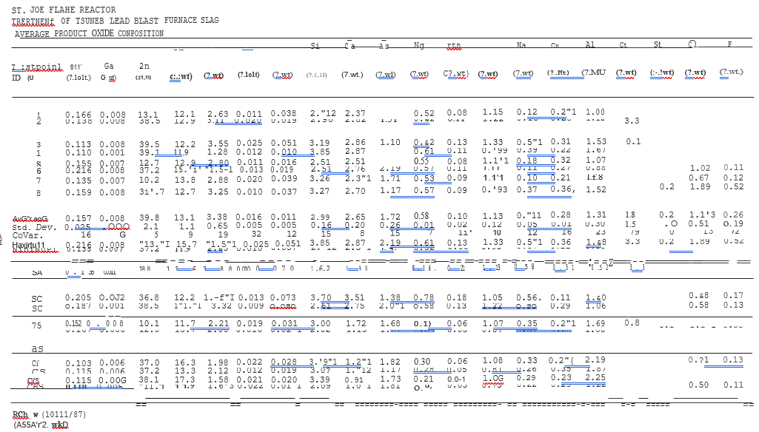

Table #6

Table #7

Arsenic content in product oxide average 1.75% for five samples. This represents 85.2% of the arsenic in the slag feed reporting to the oxide.

Linear regression equations were fitted to the observed recoveries in the test matrix. Statistical data including regression coefficients, regression residuals and analyses of variance are summarized in Appendix B. Overall, the linear models do not accurately predict metal recoveries, as indicated below by the low values of "R-Squared" in the goodness-of-fit:

**Linear Regression Models**

Metal Recovery

To Product Oxide R-Squared(l)

Germanium 41.7%

Gallium 50.8%

Zinc 19.6%

Lead 63.8%

Note:(1) Explained variation about the mean for the linear models of metal recoveries as a function of the four independent parameters of the test matrix:

(a) slag feed, (b) oxidant composition, (c) reactor

co/co2 ratio and (d) reactor operating temperature.

As mentioned, the primary cause of low smelting efficiencies was attributed to problems with coal combustion. This problem was probably large enough to significantly mask true effects of varying operating conditions on smelting performance.

The regression residuals appear to be negatively or positively skewed and are not normally distributed. This indicates the possible existence of some curvature to the effects of operating conditions on metal recoveries; hence, quadratic models may be more appropriate than linear models. However, additional tests would be required to develop these quadratic models.

Although the linear models are not accurate, they can be used to indicate the general trends of metal recoveries to varying operating conditions. Based on the linear models, contour maps of metal recoveries as a function of: (1) oxidant composition vs. Slag Feed, and (2) Reactor temperature vs. Reactor CO/CO2 ratio were generated.

It can be seen that germanium, gallium, zinc and lead recoveries are projected to increase as slag feed ( lbs./min) increases and oxidant composition (% o2) decreases, i.e. oxygen.

Enrichment (% o2) decreases, see Figure B. These effects were seen with earlier test programs and were attributed to: (1)

Aerodynamic Effects - greater turbulence in the reactor at higher mass throughput to promote better mixing between feed particles and reducing gases, and/or (2) Thermodynamic Effects more favorable chemical equilibria at higher oxidant feed per

unit of slag feed. A detailed discussion is presented in Appendix c.

It has been known that reactor capacity is greater than the off-gas system capacity - which is a bottleneck of the demonstration plant. This forces us to reduce reactor throughput, in order to be able to complete test points; hence, reactor performance decreases.

Gallium, zinc and lead recoveries are projected to increase with increasing reactor temperature, whereas, Germanium recoveries were not responsive, see Figure c.

Recoveries varied more to reactor gas co/co2 ratio. The lack of consistent responses was attributed to difficulties in coal combustion.

In conclusion, Germanium, gallium, zinc and lead recoveries to product oxide were lower than anticipated. The limitations of the linear models to predict metal recoveries in

product oxides were primarily attributed to the difficulties in using coal as a fuel source and, secondarily, to the non-linear (7 effects of operating conditions on recoveries. However, general trends of the linear model indicate that recoveries can be improved at higher slag feed rates and lower oxygen enrichment, i.e., high reactor mass throughput.

B. COKE BREEZE TESTS

On August 13, 1987, the first fuming test was completed while using coke breeze, i.e. Test point ltSA. Two additional tests were completed with coke breeze and were identified as Test points #SC and #SC, which corresponded to Test points # S and #8 using coal. These test points were run to provide some comparisons of process performance as a function of fuel type. Metal recoveries for coal and coke test points are compared in Table #8.

Test points #SC and #SC generated product oxides with higher germanium contents and recoveries than Test points #5 and #8. Gallium, zinc and lead recovery values were generally about the same or higher. This suggests that more stable combustion obtained with coke breeze increased reactor.

performance and improved metal recovery. Since coal is the fuel of preference for Tsumeb, efforts will be directed at improving coal combustion performance and control.

Even with coke fines, further improvements in combustion efficiency should result in higher metal recoveries. Our previous test experience with lead blast furnace slag from the St. Joe Herculaneum Smelter resulted in 85-92% zinc recovery. We should be able to achieve these zinc recoveries as well as high Germanium recoveries with proper combustion system performance.

Figure B. St., Joe Flame Reactor Process

Tsumeb Slag Fuming Tests

Linear Regression Model Contour Maps

Oxidant (%02) versus Slag Rate (lb./min)

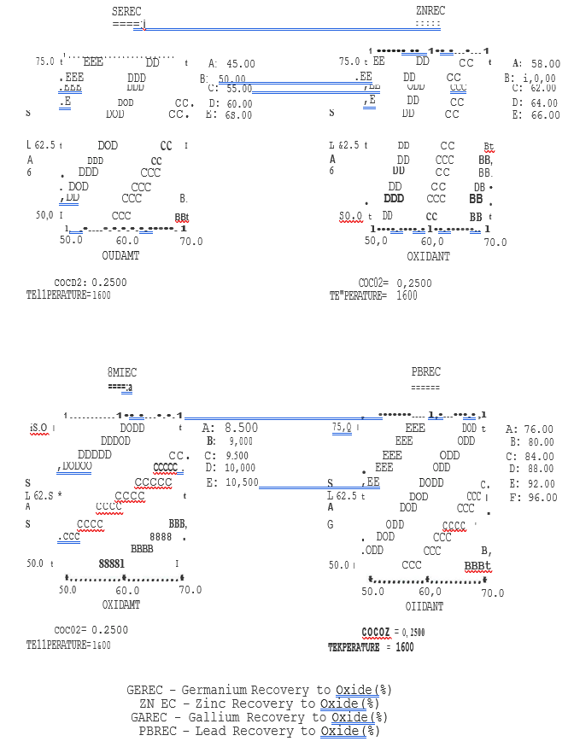

Figure C. St., Joe Flame Reactor Process

Tsumeb Slag Fuming Tests

°Linear Regression Model Contour Mapa

Reactor Temperature (°C) versus CO/C02Ratio

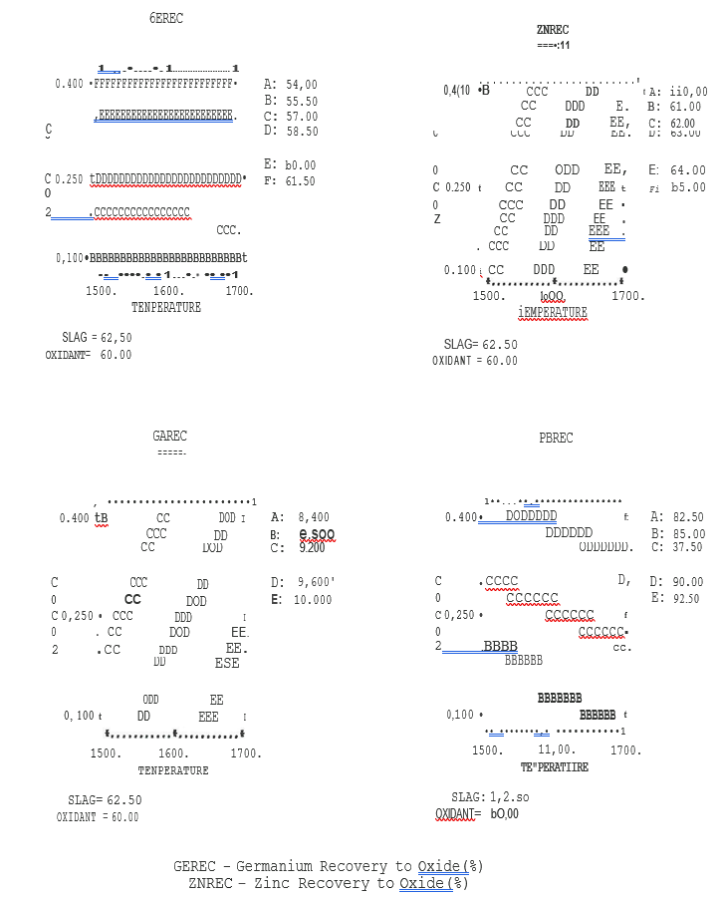

Table JS

Tsumeb Slag Fuming Tests

Coal/Coke Test Point Comparison

Test point Fuel Metal Recoveries to Oxide (%)

|  |  |  |  |  |
| --- | --- | --- | --- | --- |
|  | Ge | Ga | Zn | Pb |
| 5 Coal | 68.0 | 9.9 | 76.4 | 97.3 |
| SC Coke | 77.2 | 15.8 | 66.1 | 92.9 |
| SA* Coke | 69.0 | 15.4 | 81.1 | 93.S |
| 8 Coal | 53.9 | 8.9 | 56.4 | 84.4 |
| 8S** Coal | 52.0 | 8.2 | 58.1 | 83.5 |
| 8C Coke | 70.5 | 8.4 | 66.1 | 94.6 |

*Point SA had higher than 5 and SC. feed rate and lower CO/CO2 and temperature

**Point 8S is the same as Point 8, except for sulfur addition in 8S.

C. SULFUR ADDITION TESTS

Germanium sulfide fuming is Germanium thermodynamically more favorable that Germanium fuming. The reactions to be considered are:

(1) Ge fuming,



Such that,

s

K =-----------------------------------------------

aGe02

(2) GeS fuming



Such that,



K =-------------------------------------------------

aGe02 * PS02

For germanium fuming at 1417 deg-C and co2; co of 5, the equilibrium partial pressure of Ge is 5.17 ppm, i.e., K = 0.013. For Germanium sulfide fuming at the same temperature and co2; co ratio but with 0.5% so2, PGeS is to 4800 ppm, i.e., K = 60,338. If so2 was increased to 2% and co2Jco ratio held constant, PGeS increases to 1.9 atmospheres.

Interestingly, at higher temperatures in 1727 deg-C and 5.O CO2/CO ratio and 2%S02,

PGeS decreases to 2000 ppm, i.e., K = 6223.

Test points 17S (low temperature) and #8S (high temperature) were run with sulfur additions to evaluate Germanium sulfide fuming, i.e. corresponding to Test points #7 and #8, respectively, which involved fuming without sulfur. Pulverized elemental sulfur was manually fed into the reactor along with the slag feed. Enough sulfur and extra oxygen were.

added to produce about 2% so2 in the reactor gas. To maintain constant co2;co ratios, coal feed was not changed. Operating temperatures would slightly higher due to the combustion of sulfur.

In general, sulfur addition caused minor increases in Germanium content but did not significantly increase Germanium

recovery to the product oxide. If the thermodynamics of GeS fuming were applicable, true effects could have been masked by the method of sulfur addition, the use of elemental sulfur and/or relatively unstable coal combustion. Overall, the two attempts to increase germanium recovery to the product oxide by fuming GeS with sulfur addition were not successful.

D. COARSE SLAG TESTS

Coarse slag was treated with coal (Test point #C7 and #C8), and coal and sulfur additions (Test points #C7S #C8S) and compared with previous tests with milled slag and coal (Test points #7 and 8).

The major change was the decrease in germanium, gallium, zinc and lead recoveries while treating coarse slag.

Recoveries dropped by about one fourth to one half. This was attributed to insufficient residence time required to fume metals from the large coarse slag feed particles. Due to the large decrease in recoveries, the treatment of coarse slag is not recommended.

Test points #C7S and #C8S with sulfur addition did not result in metal recoveries much different from Test points #C7 and #C8 without sulfur additions. This coincides with the results obtained while treating milled slag with sulfur.

SECTION VIII

RECOMMENDATIONS

The following recommendations are made to further demonstrate the St. Joe Flame Reactor Process for fuming Tsumeb lead blast furnace slag. During the August 1987 program, fuming slag and recovery of germanium, gallium, zinc and lead was inhibited by complications with coal combustion. Fuming tests with coke breeze resulted in higher metal recoveries.

Overall, we believe that the problems with coal ignition and combustion versus coke fines are related to the ignition speed of the volatile components as well as the residence time for gasification in the burner. While we are proceeding with detailed calculation of these parameters, we will recommend decreasing the residence time in the mixing section of the burner to prevent premature ignition, and increasing the residence time in the lower burner section to allow more time for complete reaction of the more complex volatiles in the

coal. The feed arrangement for the coal and o2/air mix will be changed and a slightly longer-diameter burner will be used in the upcoming coal combustion tests. We will also make improvements to our reactor gas sampling and analysis system to insure reliable tracking of CO/CO2 and carbon utilization.

Our goals would be to obtain coal ignition and combustion which are as stable as those obtain while using coke fines. The basis for comparison would be: ( 1) % carbon utilization

( >90%), (2) reactor gas CO/co2 ratio; (3) gas temperature in the burner section, and (4) overall metallurgical performance.

We recommend:

(A) MODIFY and test the burner section to eliminate premature coal ignition, backpressure on the fuel injection pipe and improve operations with coal,

(B) IDENTIFY' mineralogical species in the Tsumeb slag and St. Joe product slag and oxide to determine if any particular germanium, gallium, zinc and lead compounds are preferentially fumed over others,

(C) EXAMINE the potential of fuming germanium sulfide by the addition of gaseous sulfur dioxide instead of elemental sulfur,

(D) EVALUATE the product oxide and slag for post-treatment testing initially desired by Tsumeb,

i.e. leaching oxide for germanium recovery and testing slag for use as a cement ingredient.

(E) PERFORM additional tests on slag fuming while firing the process with coke fines to quantify the capabilities of the Flame Reactor Process without the complications of coal combustion - delineate the effects of fuel type on combustion performance and smelting performance, and

(F) PERFORM additional slag fuming tests with coal and with the modified and improved burner to make a final determination of Flame Reactor Process capabilities.

We are proceeding with the coal combustion testwork and are willing to work with TCL on testing a second small lot (20-25 tons) of slag, including cost sharing. Further discussion of this program will be presented in our commercial proposal scheduled to issue in late December.

APPENDIX A

COMPOSITION OF INDIVIDUAL SAMPLES

ST. JOE FLAl1E REACTOR

TREATHENT OF TSUl1EB LEAD BLAST FURNACE SLAG

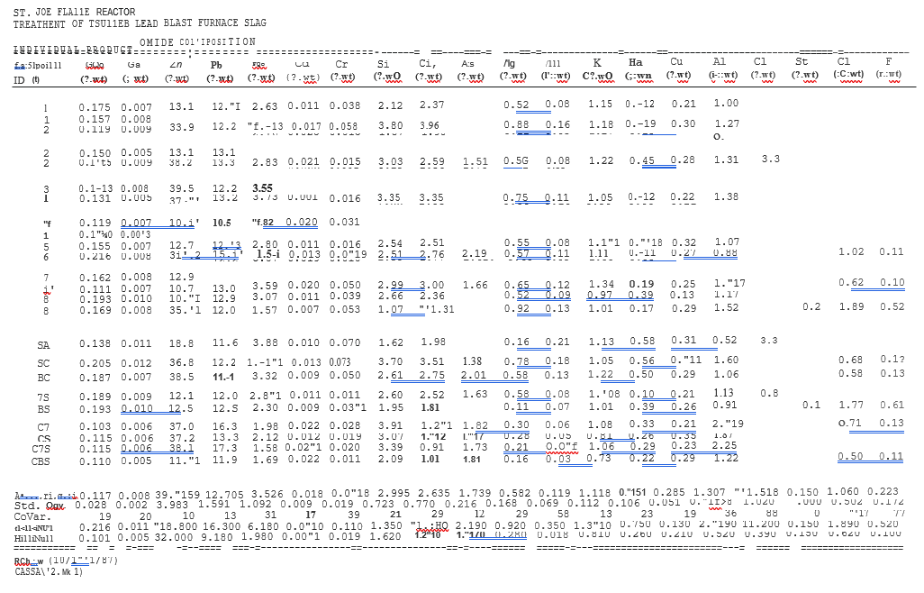

ST. JOE FLAHE REACTOR

THERE THEN OF TSUMEB LEAD BLAST FURNACE SLAG

INDIVIOURL PRODUCT -S LAG COHPOSITION

APPENDIX B

SUMMARY OF STATISTICAL ANALYSIS

1) Summary of the Quality of Linear Regression Models

2) Coefficients of Linear Regression Models

3) Table of Residuals

4) Analysis of Variance (ANOVA) Tables

Definitions:

(1) RESIDUE = Residue feed rate (lbs./min) from test matrix

(2) OXIDANT = Oxidant composition (%02) from test matrix

(3) COC02 = Reactor gas composition (CO/CO2) ratio from test matrix

(4) TEMPERATURE = Reactor gas temperature (deg.-C) from test matrix

(5) GEREC = Recovery of germanium to product oxide (%)

(6) GAREC = Recovery of gallium to product oxide(%)

(7) ZNREC = Recovery of zinc to product oxide(%)

(8) PBREC = Recovery of lead to product oxide(%)

(1) Summary of the Quality of Linear Regression Models

(a) Standard deviation about the regression is a measure of the uncertainty in predictions using the regression equation.

(b) The variabi1ity of the observed data about the mean and explained by the regression equation (the R-squared coefficient of multiple determination) are shown.

(c) The condition number of the design matrix is a measure of the orthogonality of the matrix. This number quantifies the "goodness" of the experimental design, i.e., an ideal set of orthogonal experiments has a number of one; conversely, as orthogonality decreases, the condition number increases. The condition number is dependent upon the chosen factor settings, the numerical values chosen for the factors, and the regression model. The high condition numbers obtained are most likely due to the apparent non-linear correlation of the experimental results to varying process conditions.

(d) This data analysis was limited to linear mode1s due to the two-level Plackett-Burman text matrix.

Summary of the Quality of Linear Regression Models

GEREC:

standard deviation about the regression= 12.78 explained variation about the mean CR-squared) = 41.69% condition of design matrix= 54.85

model= LINEAR

GAREC:

standard deviation about the regression= 1.242 explained variation about the mean CR-squared) ; 50.77% condition of design matrix: 54.85

model= LINEAR

ZNREC:

standard deviation about the regression= 10.73 explained variation about the mean CR-squared) = 19.64% condition of design matrix= 54.85

model= LINEAR

PBREC:

standard deviation about the regression 7.620 explained variation about the mean (R-squared) = 63.76% condition of design matrix= 54.85

model= LINEAR

(2) Coefficients of Linear Regression Models

(a) Coefficients of each linear model are stated for each matrix variable.

(b) Standard error is a measure of uncertainty in the estimate. If the ratio of the regression coefficient to standard error is large, the coefficient is statistically significant.

(c) T-value is the ratio of the regression coefficient to standard error. Along with the degrees of freedom in the error analysis, the T-value is used to test the hypothesis that the coefficient is nonzero.

(d) Confidence coefficient <>0 is the corresponding percentage confidence level for the T-value. As the significance of a coefficient increases, the percent confidence coefficient increases. Note that a majority of the linear regressions have high percent confidence levels for the "1 (constant)" term which indicates relatively constant recoveries, independent of varying process conditions.

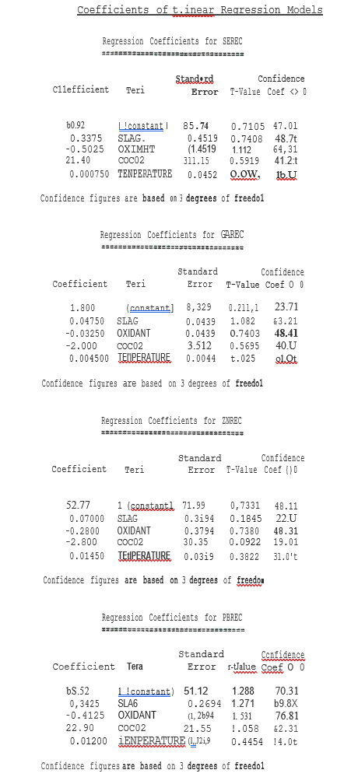

(3) Table of Residuals

(a) Controlled factors are the independent variables of the test matrix.

(b) Characteristics included:

Observed recoveries,

Predicted recoveries by the regressions model, and

Residuals which are the differences between observed and predicted recoveries.

(c) Plots of residuals show the distribution of the residuals about zero. If residuals are relatively random (non-systematic), the plot should have an approximately normal distribution. Since most plots do not approximate a normal distribution, a systematic error is probably present; namely, utilizing linear models to correlate apparent non-linear characteristics

Table of Residual

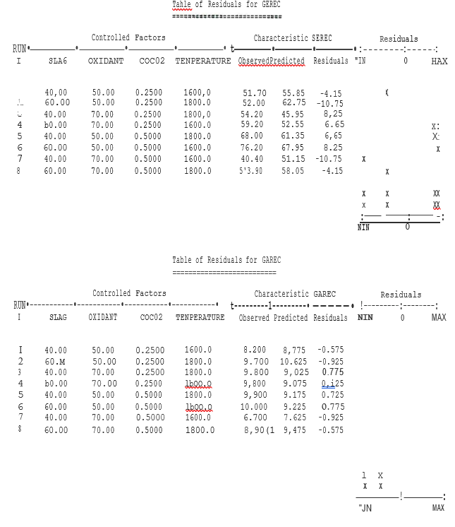

Table of Residuals ,cont’d

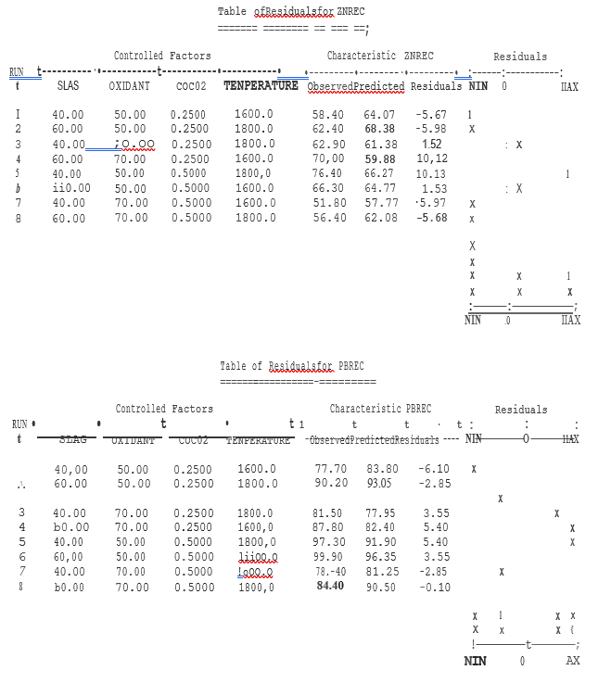

(4) Analysis of Variance (ANOVA) Tables

(a) The Analysis of Variance (.ANOVA) tables help quantify the usefulness of the linear regression equation. These tables have a standard presentation.

(b) The F-ratio values are the ratios of the mean square (MS) values of regression-to-residual. The F-ratio is used to determine whether at least one coefficient in the regression is nonzero (significant). The corresponding percent confidence level of the regression is stated for the F-ratio at the appropriate degrees of freedom. Confidence levels of about 95+% are customarily selected and considered statistically significant.

Analysis of Variance (ANOVA) Tables

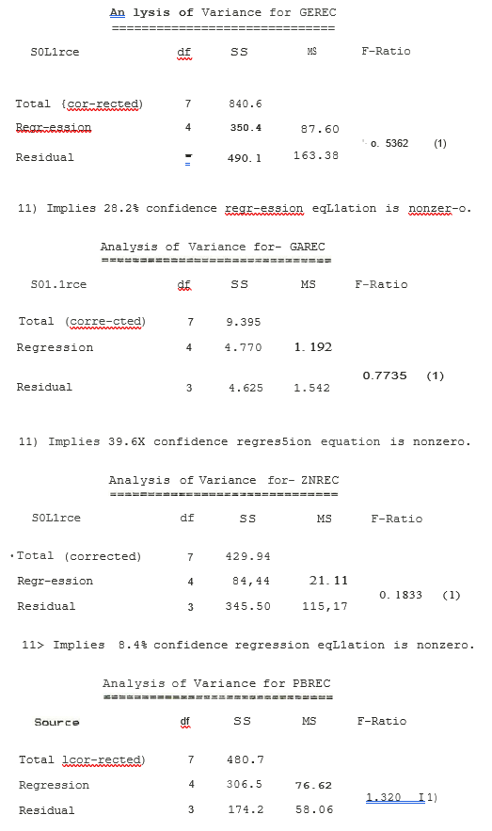

Ill Implies 57.6% on idence r-egression eqL1ation is nonzero.

b. Thermodynamic Factor

At constant slag feed rate and high total oxidant flow rate, the thermodynamic chemical equilibria would favor more metal fuming and increase germanium, gallium, zinc and lead recoveries to product oxide. For example, the zinc oxide reaction with CO can be used to illustrate this factor, as follows:



the equilibrium constant is



K =



At higher gas volume due to lower oxygen enrichment, (at constant temperature, co2/co ratio and zno activity) more zinc units per unit of feed must react to maintain the equilibrium (the same values of Pzn and K). This provides more driving force to fume zinc; hence, higher zinc recovery would be achieved.

We can isolate and test these two factors to determine which theory is valid.

To test the aerodynamic operated at higher throughput factor, the reactor can be by proportionately increasing dust, coke and oxidant feeds, e.g., constant dust/oxidant ratio. This will increase total gas flow rate in the reactor and not change the chemical equilibria. Zinc recoveries should increase if the aerodynamic theory is true.